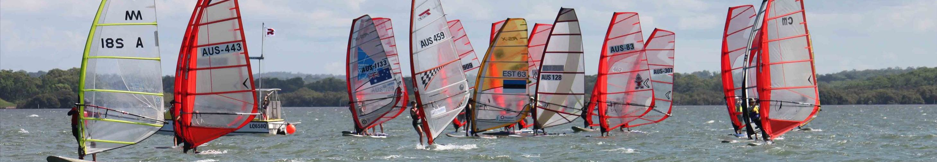
COME TO AUSTRALIA!
Would you like to come for the Raceboard World Championship, (including Hybrid 310 class World championship) in Australia in 2016?
We are planning the Worlds in Brisbane in November 2016. Without you it might not happen!
Where: Royal Qld yacht Squadron, Manly, Brisbane.  http://www.rqys.com.au/  When: 17th - 25th November 2016  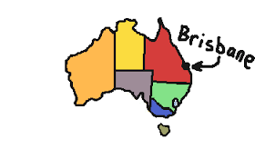  There is a range of accommodation, including camping, apartments and hotels. | 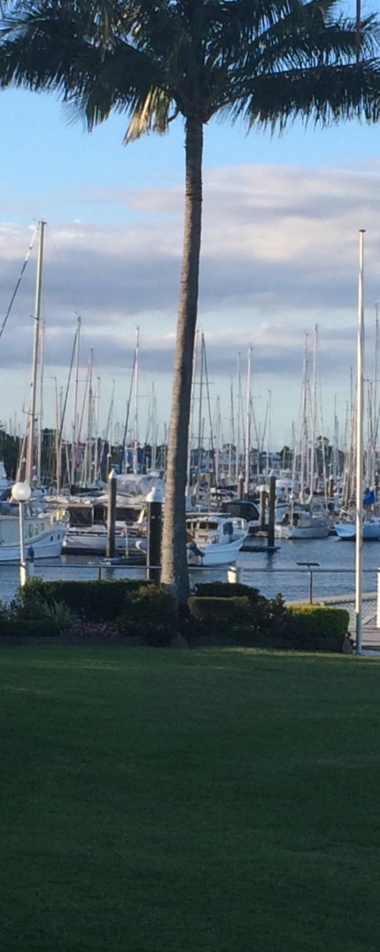
https://www.youtube.com/watch?v=rMdbVHPmCW0
Please let us know by sending an email:
- Are you coming?
- What would make you decide to come if you are unsure?
- Would you be interested in 2nd hand gear charter?
Send an email to lissamcm@gmail.com and let us know what you think. Tell us what would make it easier for you to join us HERE in Brisbane in 2016!

