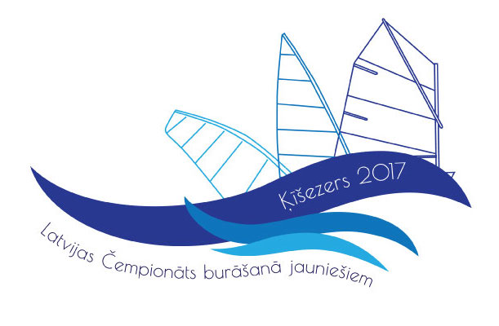

LATVIAN OPEN SAILING CHAMPIONSHIP 2017

10-13 August 2017
Sailing Club 360. Riga, lake Kisezers. R.Feldmana str. 8a

ACCOMODATION INFORMATION

Athletes have an access to the parking lot for your van or camper at Sailing Club 360

Two nearest hotels nearby the event site are:

Hotel MEŽAPARKS (200m from Sailing Club 360): http://www.scmezaparks.lv/en/hotel/ or booking.com

Hotel ĶEIZARMEŽS (400m from Sailing Club 360): http://www.hotelkeizarmezs.com or booking.com
By booking room in this hotel use our special promo code WIND and get lower price

The MAP
